LC VARIANT EDITIONS

Variant edition cataloging occurs when the work in hand has either member copy or no copy and there is either LC copy or PCC copy for an edition that varies in some way from the work in hand. These variations typically occur in edition statement, publisher, date of publication, series, and occasionally title. In variant edition cataloging, the cataloging for the work in hand is based on the catalog record for the variant edition, especially in the areas of subject headings and call number. (see examples on p.3)

- If there is member copy for the work in hand import the catalog record and make changes based on the variant edition record (usually a LC 9110 or sometimes 9660).

- If there is no copy for the work in hand create a new catalog record and make changes based on the variant edition record (usually a LC 9110 or sometimes 9660).

Fixed field

Make all appropriate changes in fixed field values, paying particular attention to Publication Status, Dates, Place of Publication, and Cataloging Source. (This should be d if cataloging member copy and no copy)

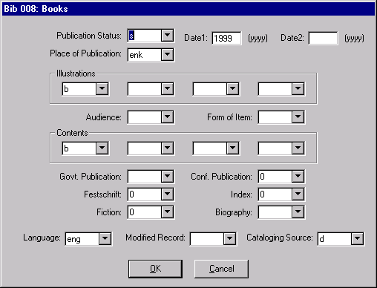

Variable fields

Make all appropriate changes in the variable fields, paying particular attention to the following:

020 Usually, but not always, different.
- Often there is some variation in title, subtitle, or exact wording of statement of responsibility.
- May have varying edition statement.
- Publisher is very often different; same with the date of publication.
- May vary.
4xx May vary.
- Pagination of bibliography often varies.

Call number

Use the call number from the LC or PCC copy and adjust year if necessary. Often the call number for the work in hand will be identical to that of the variant edition with the exception of the date. To distinguish two editions that share the same date of publication, add the work letter “b” to the end of the date in the call number.

E.g. LC copy has call number HA31.B46 1999
Your variant ed. gets call number HA31.B46 1999b

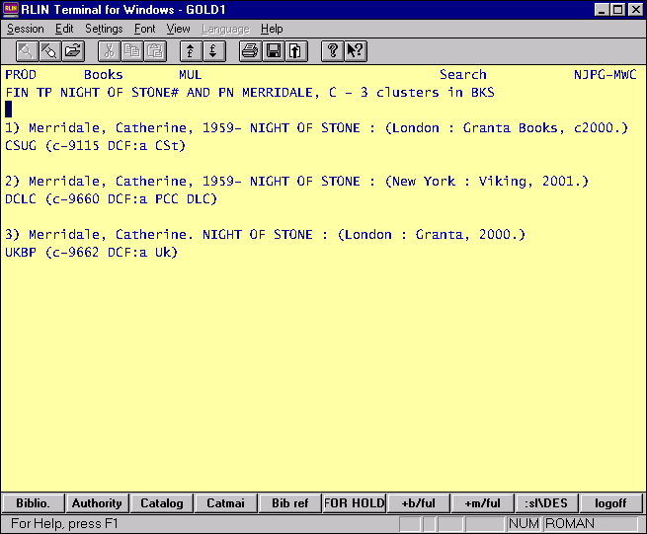

- We have London : Granta, c2000 in hand

- Pass member copy for work in hand

- Compare with LC copy for New York : Viking, 2001 and make changes as necessary. Name and subject headings should match exactly with LC.

- Use LC call number and adjust year if necessary to match your publication date.

